DISC Behavioral Style Interview Guide

Candidate Name: ____________________________________ Date: ____________ Position: _________________

Introduction for Interviewer

This interview guide helps hiring managers assess where a candidate falls along two key behavioral dimensions from the DISC model:

**- Energy**: Active (extroverted, fast-paced, intuitive, assertive, direct) vs. Thoughtful (introverted, moderate-paced, methodical, reserved, indirect)  
- **Environment**: Questioning (task-oriented, logical, skeptical, guarded) vs. Accepting (people-oriented, emotional, agreeable, open)

Mark each question with a check for the appropriate response type. At the end, tally all Scores. These scores can be used to plot the candidate’s DISC position.

Energy

## Question 1: Extroverted (Active) vs. Introverted (Thoughtful)

* Do you feel more energized after being around a group of people or after spending time alone?
* **Active**: (Extroverted) 'I get energy from people', 'I enjoy being around others frequently'.
* **Thoughtful**: (Introverted) 'I need quiet time to recharge', 'I prefer one-on-one or solo time'.

## Question 2: Fast-paced (Active) vs. Moderate-paced (Thoughtful)

* How would your coworkers describe the speed at which you work and make decisions?
  + **Active**: (Fast-paced) 'Quick', 'Decisive', 'Always pushing forward'.
  + **Thoughtful**: (Moderate-paced) 'Steady', 'Thorough', 'Takes time to consider'.

## Question 3: Intuitive (Active) vs. Analytical (Thoughtful)

* When you're unsure how to approach a task, do you rely on instincts or prefer to gather data first?
  + **Active**: (Intuitive) 'I trust my gut', 'I’ll figure it out as I go'.
  + **Thoughtful**: (Analytical) 'I research first', 'I like to prepare and plan'.

## Question 4: Assertive (Active) vs. Calm/Reserved (Thoughtful)

* How do you typically respond when someone disagrees with your opinion in a meeting?
  + **Active**: (Assertive) 'I stand my ground', 'I like healthy debate'.
  + **Thoughtful**: (Calm/Reserved) 'I listen first', 'I try to find common ground'.

## Question 5: Direct (Active) vs. Indirect (Thoughtful)

* When giving feedback, are you typically straightforward or do you soften your message?
  + **Active**: (Direct) 'I tell it like it is', 'I’m very clear'.
  + **Thoughtful**: (Indirect) 'I ease into it', 'I consider how it sounds first'.

# Environment

## Question 6: Task-oriented (Questioning) vs. People-oriented (Accepting)

* Do you prefer roles where you focus on completing tasks or working with people to reach a goal?
  + **Questioning**: (Task-oriented) 'I like checking things off', 'I focus on results'.
  + **Accepting**: (People-oriented) 'I enjoy team projects', 'I like collaboration'.

## Question 7: Thinker (Questioning) vs. Feeler (Accepting)

* When making decisions, do you focus more on what’s logical or how it will affect others?
  + **Questioning**: (Thinker) 'I rely on logic and facts', 'I look at the data'.
  + **Accepting**: (Feeler) 'I consider others', 'I think about the impact on people'.

## Question 8: Logic-focused (Questioning) vs. Emotion-focused (Accepting)

* In your opinion, what drives your success more—your thinking or your ability to relate to others emotionally?
  + **Questioning**: (Logic-focused) 'My analysis', 'I approach things rationally'.
  + **Accepting**: (Emotion-focused) 'My empathy', 'I connect with people'.

## Question 9: Skeptical (Questioning) vs. Agreeable (Accepting)

* When someone presents a new idea, are you more likely to challenge it or support it initially?
  + **Questioning**: (Skeptical) 'I ask a lot of questions', 'I want to see the logic'.
  + **Accepting**: (Agreeable) 'I’m open to it', 'I like encouraging new ideas'.

## Question 10: Guarded (Questioning) vs. Open (Accepting)

* When meeting new people, do you tend to share openly or keep things more private at first?
  + **Questioning**: (Guarded) 'I keep things to myself', 'I take time to open up'.
  + **Accepting**: (Open) 'I’m an open book', 'I share easily'.

# SCORE SHEET

For each question, circle the behavior that best matches the candidate’s response. Then tally the results.

## Energy Assessment (Questions 1–5)

Active responses: _____

Thoughtful responses: _____

Final Energy Score = Active – Thoughtful = _____

## Environment Assessment (Questions 6–10)

Questioning responses: _____

Accepting responses: _____

Final Environment Score = Questioning – Accepting = _____

## Quadrant Plot

Use the two final scores to plot the candidate on a DISC quadrant:

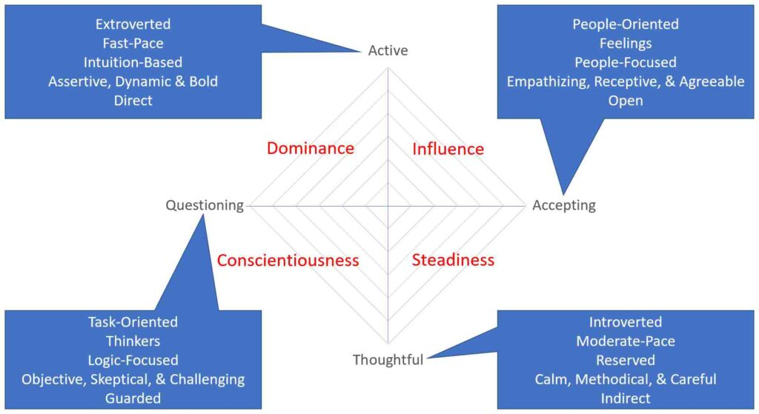

For example, if they have four Active attributes and one Thoughtful attribute, place a mark three points up from the center in the “Y” axis (4-1=3).  Do the same for the “X” axis.  The Intersection of these 2 points should identify the candidate’s primary DISC Profile.

Here is a post that explains this concept in more detail (TBD)